Events

Parties

Showers

  - Balzano Family Vineyard
  - Let us make your day amazing

Event Packages
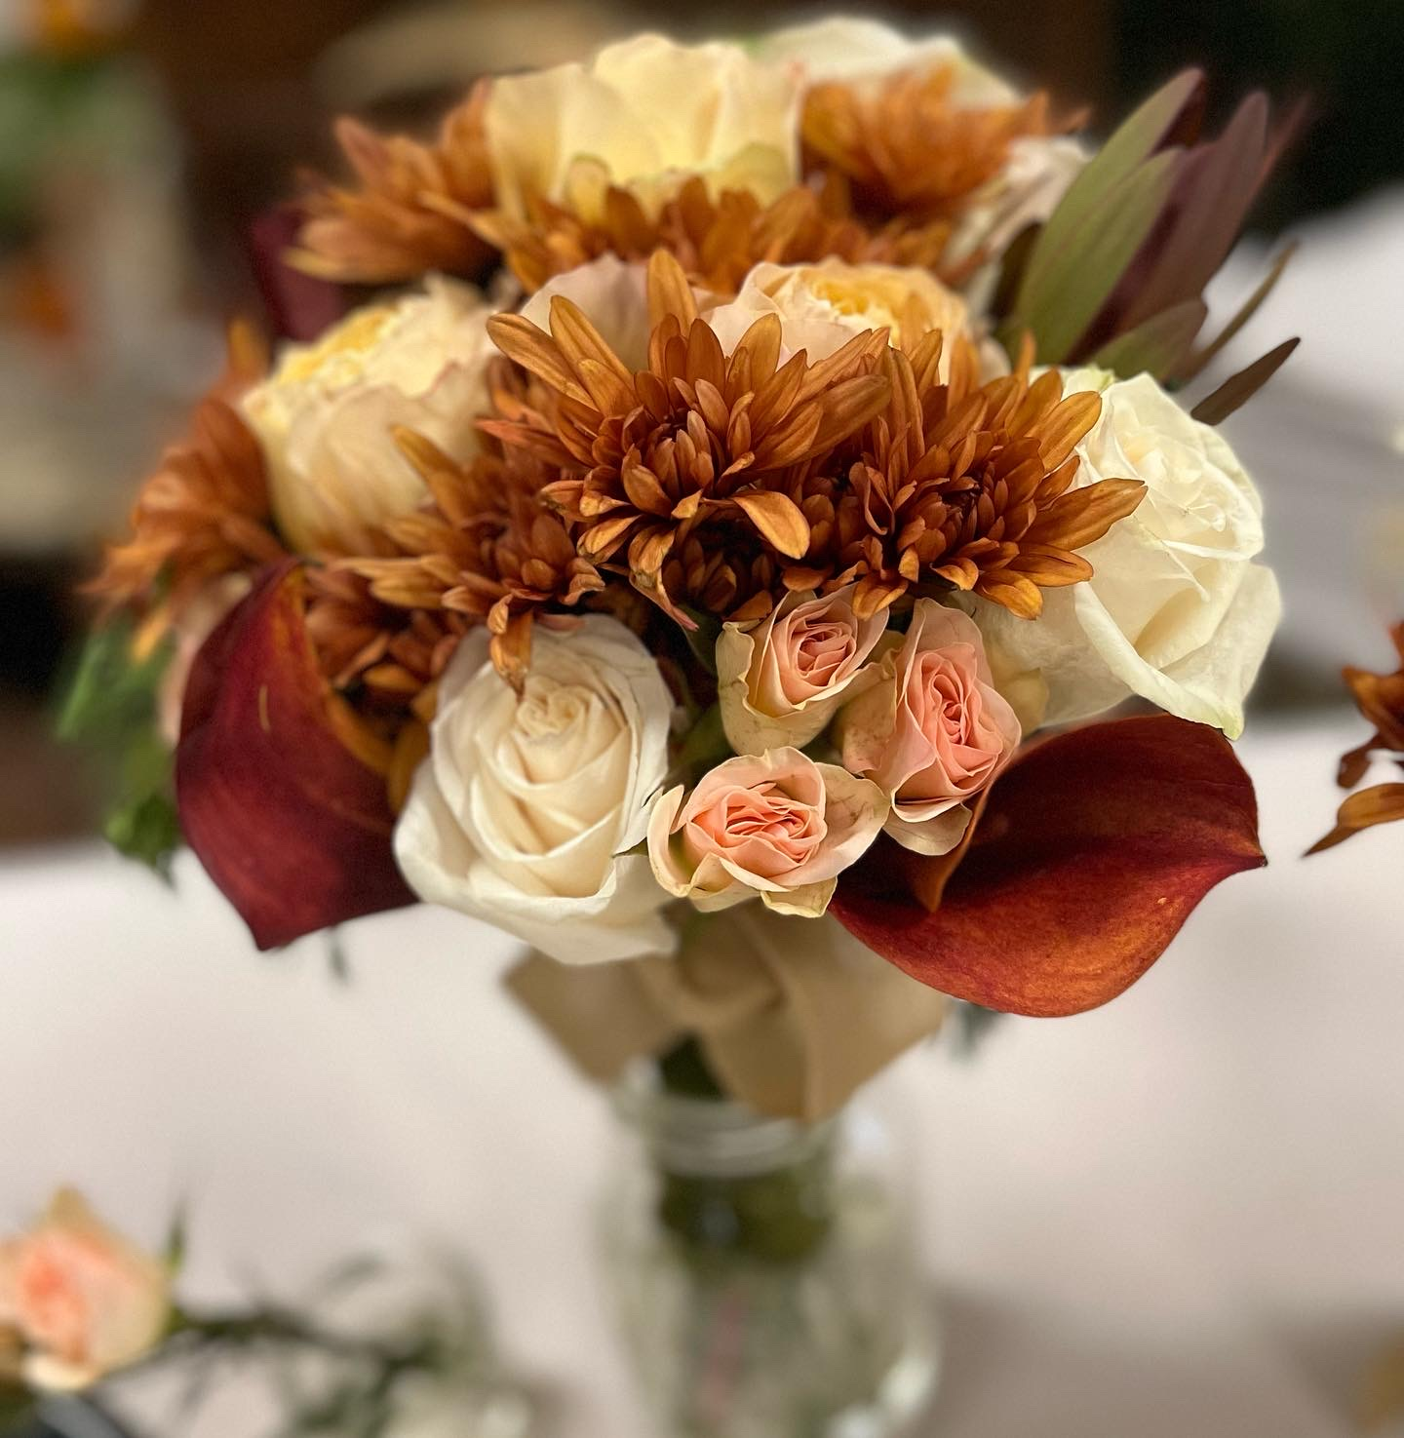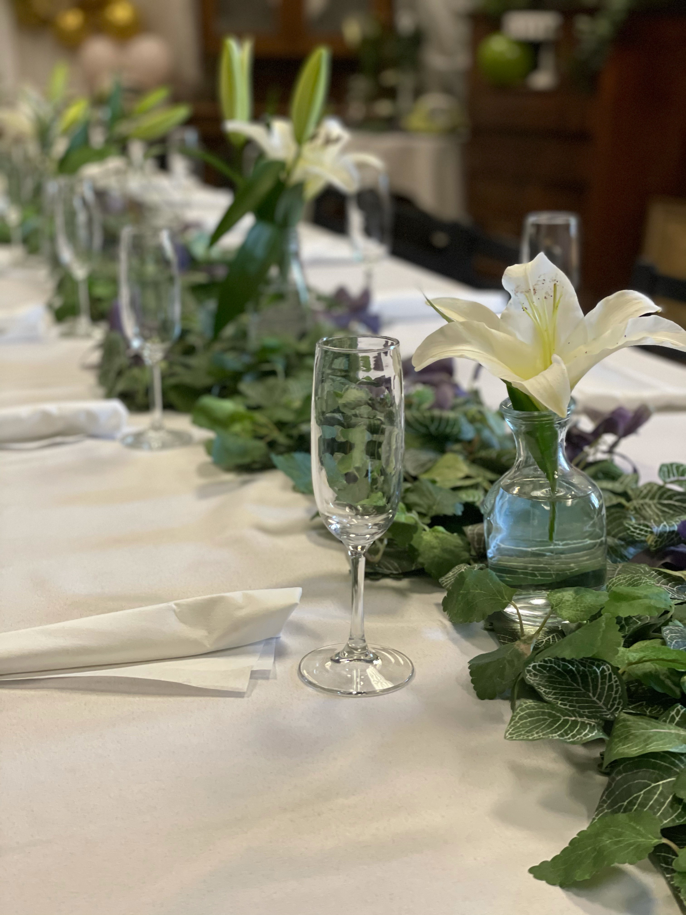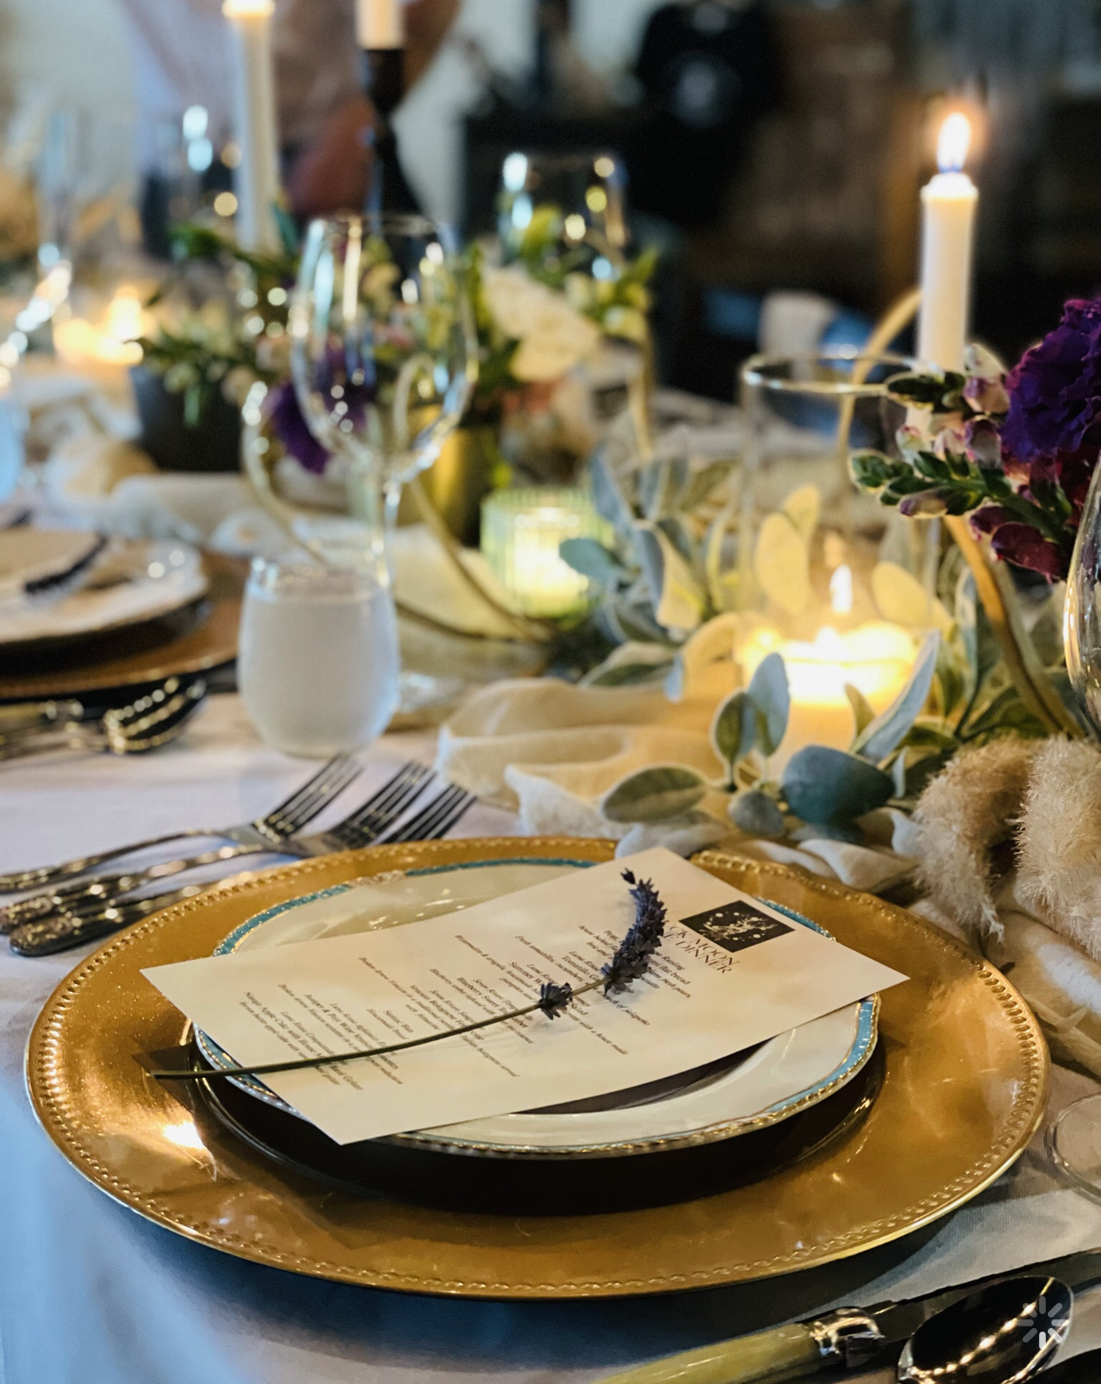

Shower/Event Package A : $35 per person
-Use of the facilities (Fairy Garden Room, Winery, WineryPatio and/or pond) a 3 hour window from the start of event to the end (all events must end by 10:30pm)
-Dinner/Lunch Option, including dessert selection
-Beverages tea, lemonade or other non-alcoholic choices.
-Customized signage
-Tableware, Table settings & linens
-Seasonal Flower arrangements-
Decorations/Décor- to match your theme or style
10-20 Guests $700
30-40 Guests $1,400
50-60 guests $2,100
70-80 guests $2,800
100-120 Guests $4,200
120-150 Guests $5,250

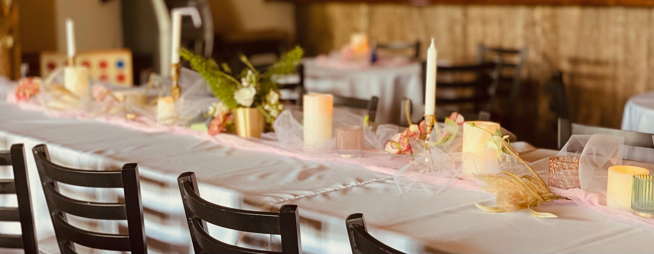

Shower/Event Package B : $25 per person
-Use of the facilities (Fairy Garden Room, Winery, Winery Patio and/or pond) a 2 hour window from the start of event to the end (all events must end by 10:30pm)
-Appetizer Selection (charcuterie board, grazing station, pastry bar)
-Beverages tea, lemonade or other non-alcoholic choices.
-Tableware, Table settings & linens
-Seasonal Flower arrangements-
10-20 Guests $500
30-40 Guests $1,000
50-60 guests $1,500
60-70 guests $1,750
100-120 Guests $3,000
120-150 Guests $3,750

Shower/Event Package C : $20 per person
-Use of the facilities (Fairy Garden Room, Winery, Winery Patio and/or pond) a 2 hour window from the start of event to the end (all events must end by 10:30pm)
-Dessert Options Only- Pie Bar, Cake, Cookie Bar, S’mores Boards
-Beverages tea, lemonade or other non-alcoholic choices.
-Seasonal Flower arrangements
10-20 Guests $400
30-40 Guests $800
40-50 guests $1,000

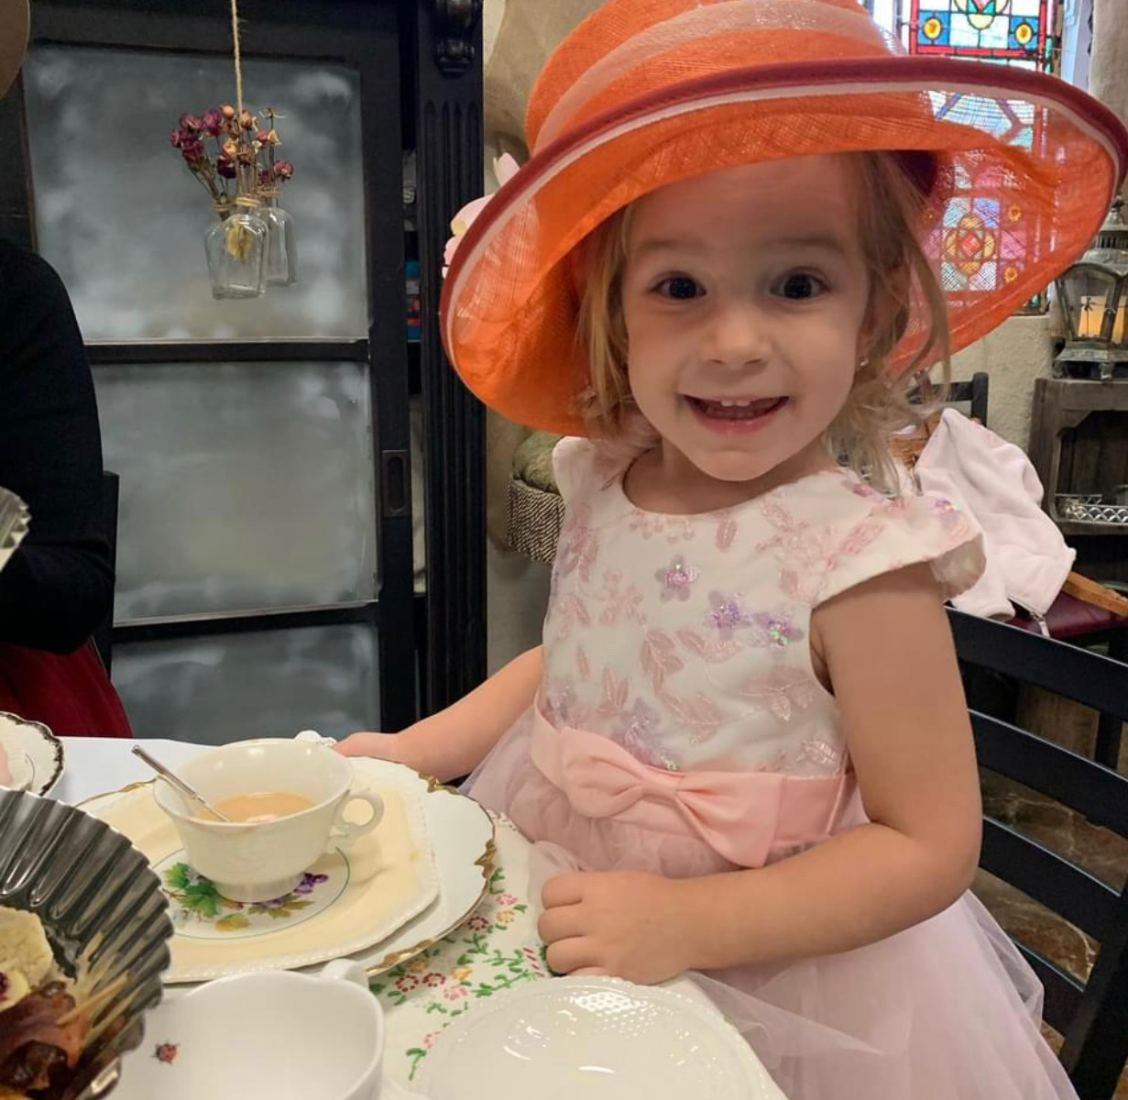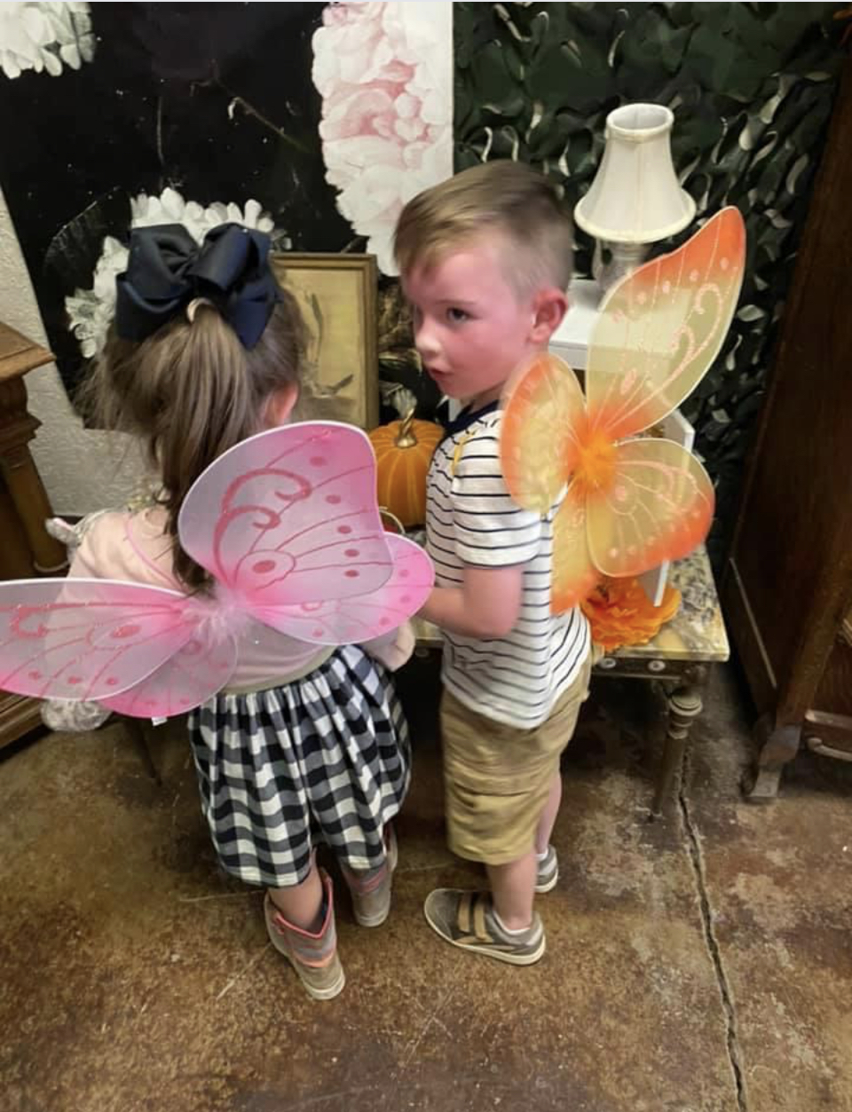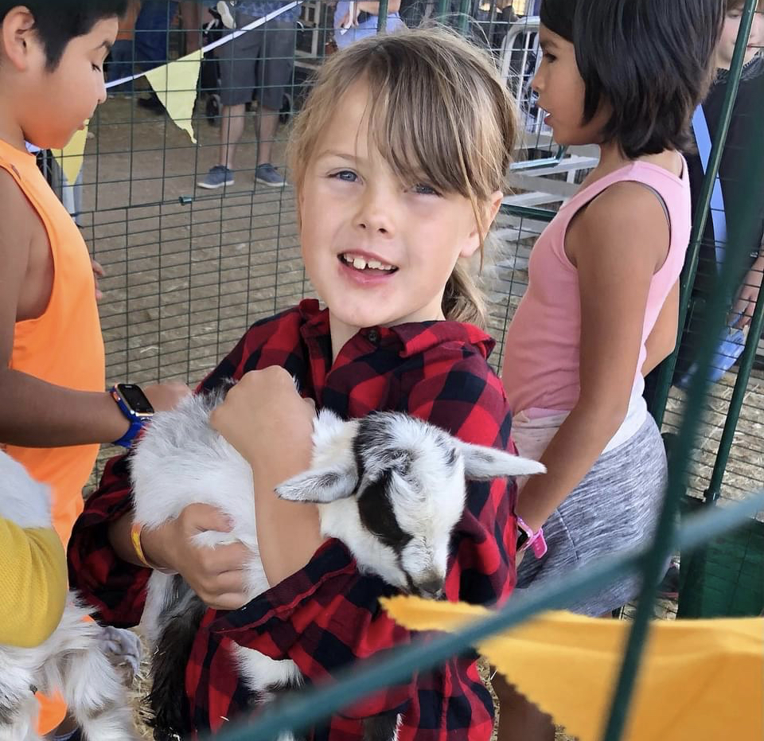

Kid Birthday Packages :
-Use of the facilities (Fairy Garden Room, Winery, Winery Patio and/or pond) a 2 hour window from the start of event to the end (all events must end by 10:30pm)
-Kid Food Option- (menu provided)
-Beverages tea, lemonade or other non-alcoholic choices.
-Petting zoo
-Customized signage
-Party Décor for theme-
Fairy Garden Tea Party-tea party décor, three course tea party, fairy wings for guests& Birthday child, petting zoo, & games
10-20 Guests $400
20-30 Guests $600
50-60 guests $1,200

Barnyard Fun-farm décor, kid friendly food, party favors for guests& Birthday child,Fishing Pond, petting zoo, & games
10-20 Guests $400
20-30 Guests $600
50-60 guests $1,200

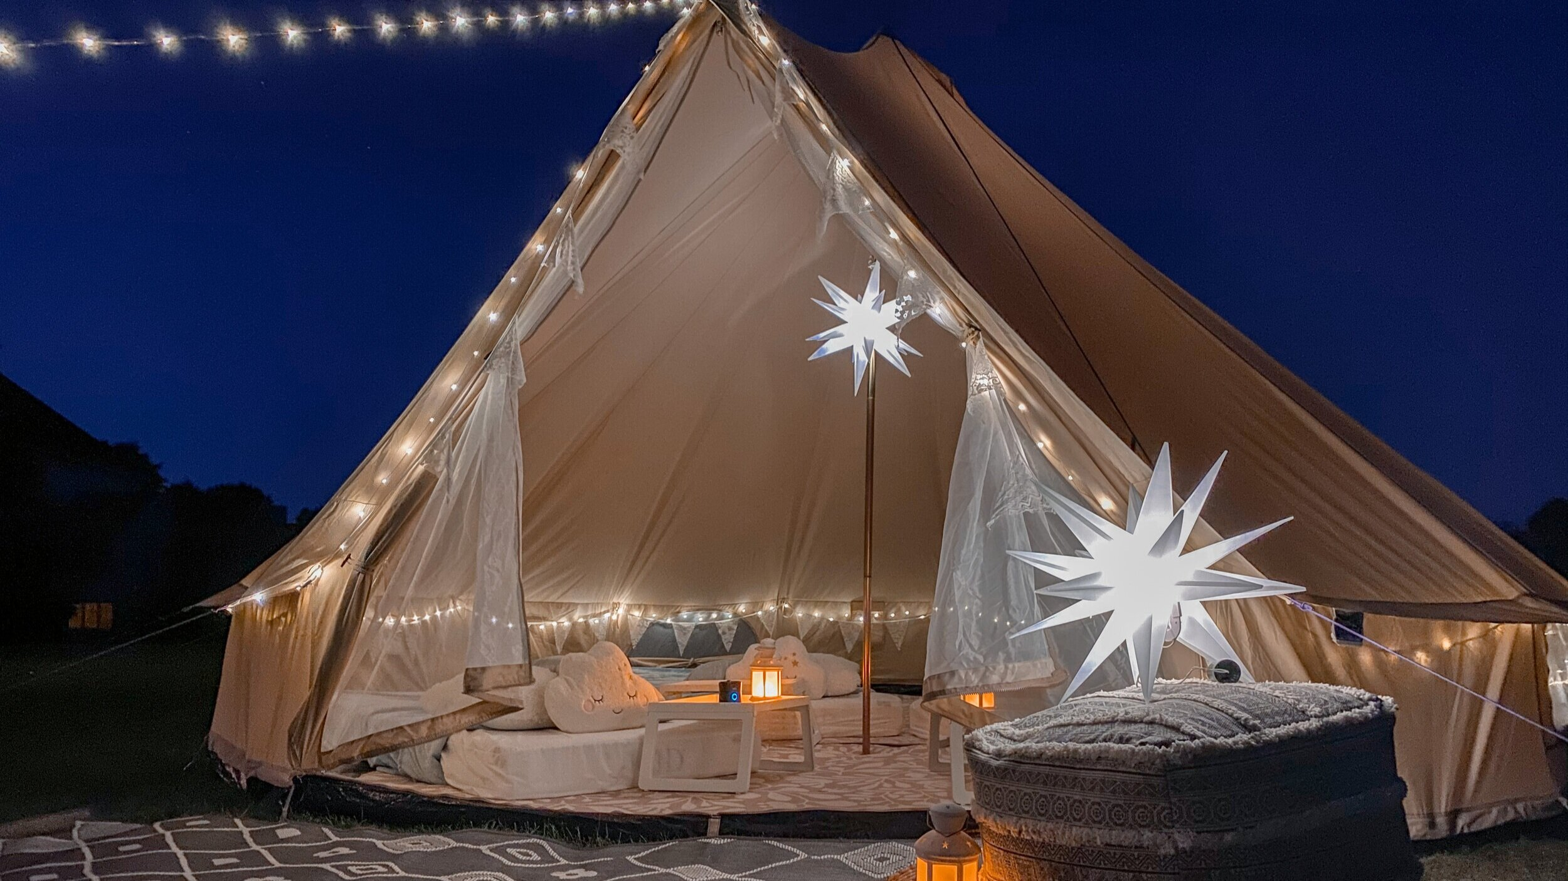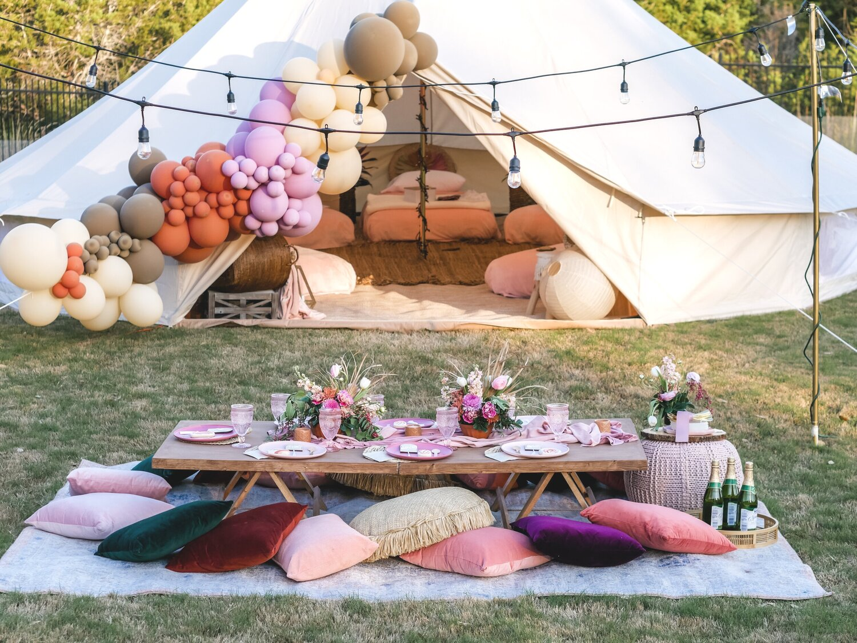

Sweet 16 Birthday Packages :
-Use of our NEW Party tent at the pond or Fairy Garden Room 3 hour window from the start of event to the end (all events must end by 10:30pm)
-Food Option- Your choice of Lunch & Dinner Menu or special menu chosen with chef -.
-Beverages tea, lemonade, two specialty non-alcoholic mocktails.
-Customized signage
-Party Décor & Flowers
- Music at Party site
-Custom party favors for guests
10-20 Guests $600
20-30 Guests $900
50-60 guests $1,800
60-75 guests $2,250
75-100 Guests $3,000

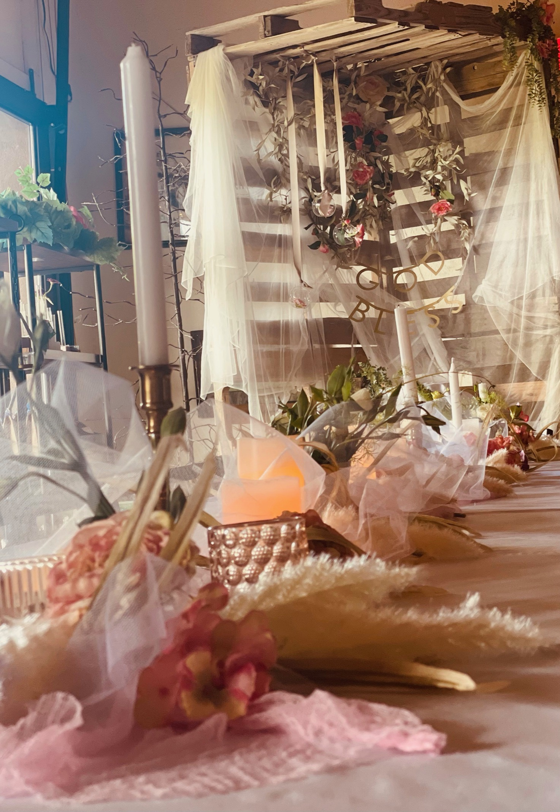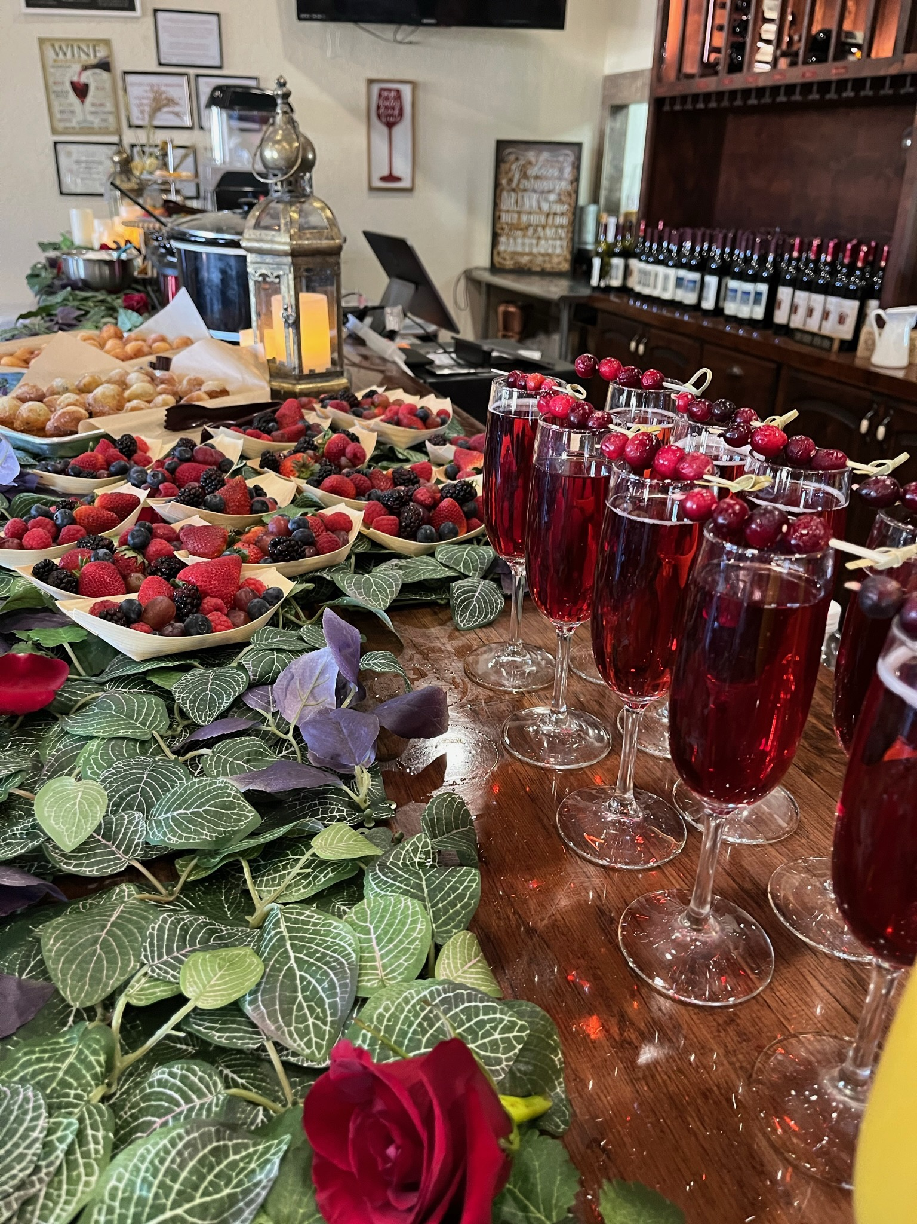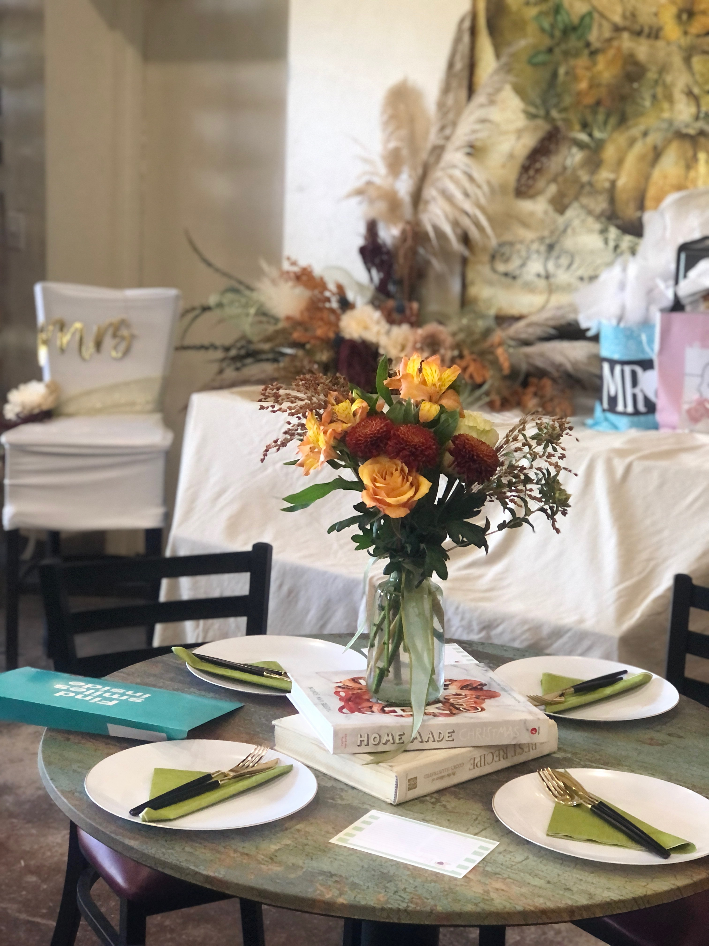
Additional Options
- Premier table settings- $2 per plate per guest
- Premier Flower arrangements- $10 per table
- Balzano Family Party favors- $4 per guest
- Champagne Toast- $3 per person
- Open Bar can be arranged with set spending limits $100 minimum
- Draping/ Premier décor options $500
- Draping of Big Barn $750 included in package A over 100 people
- Octagon with flowers $500
- Pie Bar $6 per person
- Bottled wine on table $15 per bottle, per table
- Appetizers (chosen with chef) $3-$15 per person depending on selection
- Additional Charcuterie Board $4 per person

